Day 1
Introduction to Networking Hardware Theory
1.Draw a labeled diagram of a typical home Wi-Fi setup showing a modem, router, switch, access point, and at least two devices (like a laptop and smartphone) connected to the network.
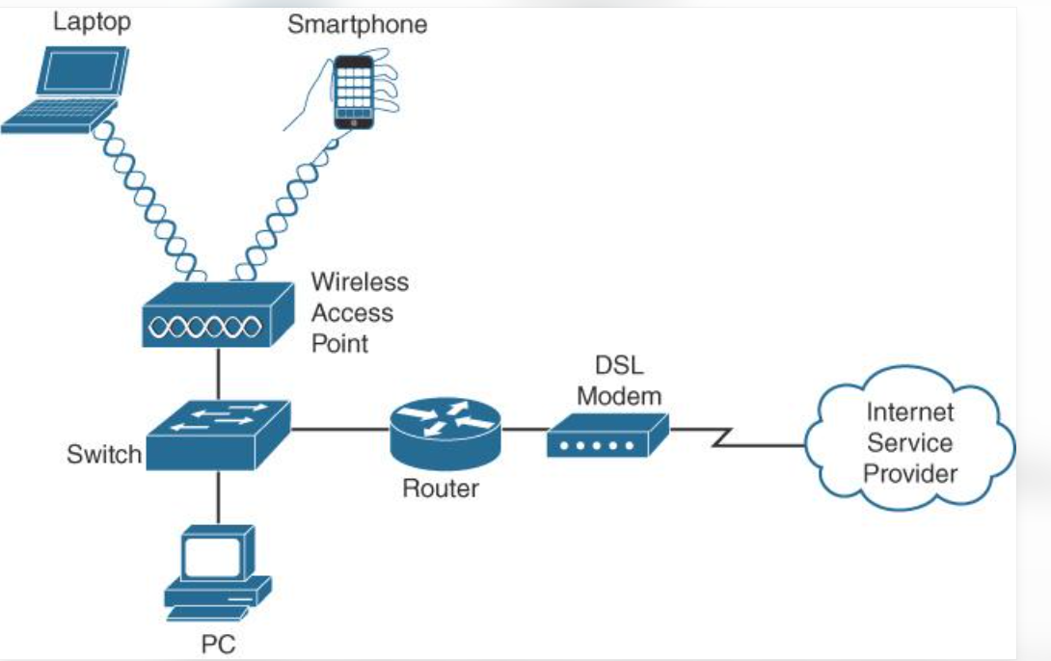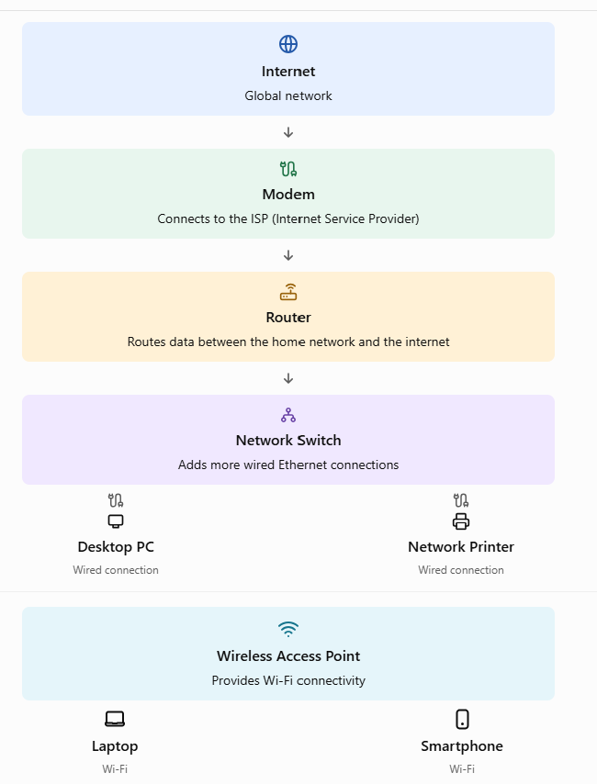
Explanation: The internet connection reaches the modem, which connects to the ISP. The router directs traffic between the internet and the home network. A switch provides additional wired connections, while an access point allows wireless devices such as laptops and smartphones to connect through Wi-Fi.
Modem: A modem connects your network to the internet service provider (ISP).
Router: A router connects different networks and directs data packets to their destinations.
Switch: A switch connects multiple devices within a local network (LAN) and forwards data to the correct device.

2.List the main function of each networking hardware device: modem, router, switch, access point, and network cable. For each, give a real-life example of where you might see or use it (for example, 'router: at home to share internet').
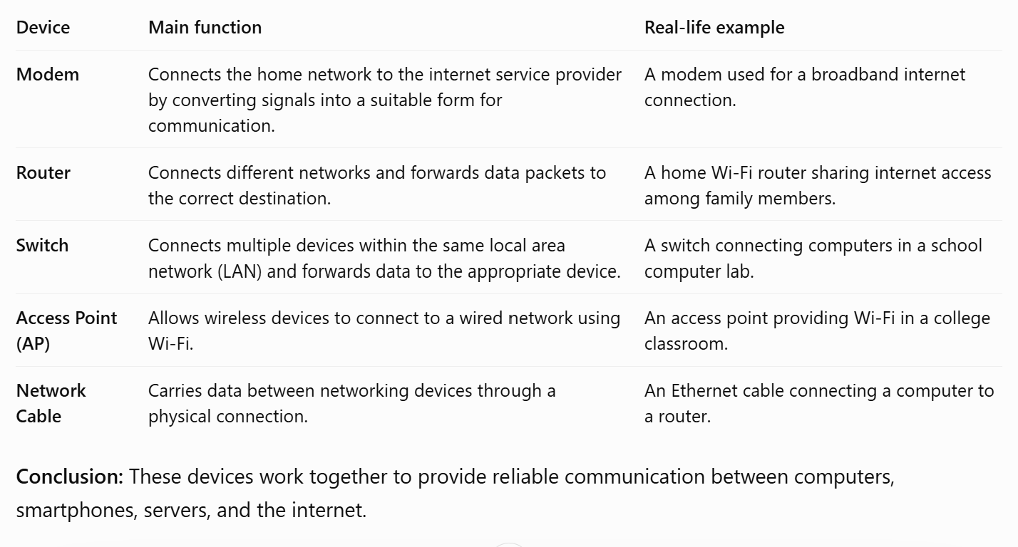
3.Take photos or find images online (with source links) of at least three types of network cables (such as Ethernet, coaxial, fiber optic) and write one line describing where each is commonly used.
1. Ethernet cable
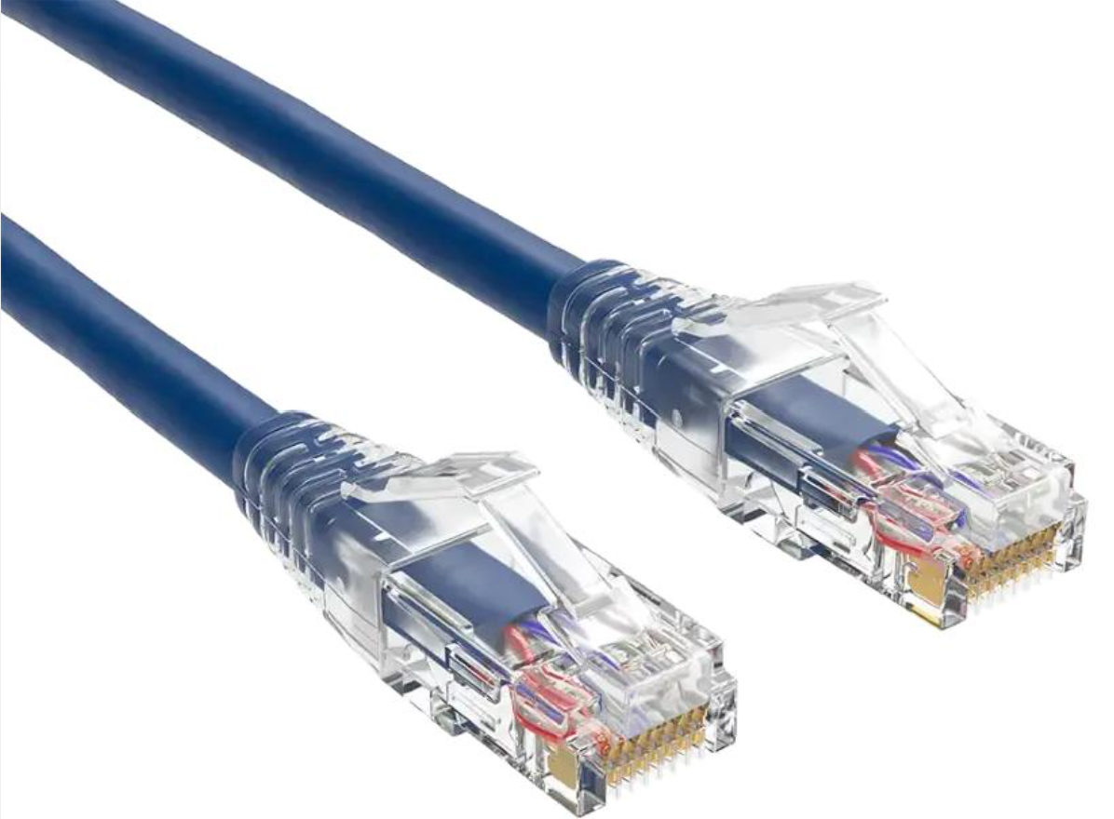
Description: An Ethernet cable, commonly a twisted-pair cable, carries data through copper wires.
Common use: Connecting computers, routers, switches, and other devices in a local area network.
Example: Connecting a desktop computer to a router.
2. Coaxial cable

Description: A cable with a central conductor, insulating layer, metallic shielding, and an outer protective covering.
Common use: Cable television, cable internet, and some communication systems.
Example: Connecting a cable internet service to a modem.
3. Fibre-optic cable
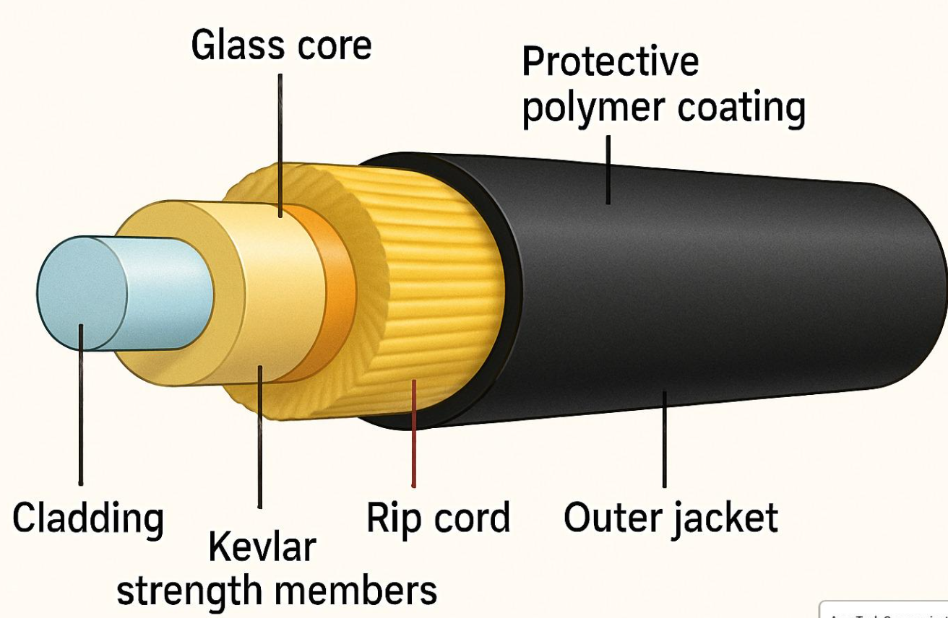

Description: A cable that transmits data as pulses of light through thin glass or plastic fibres.
Common use: High-speed internet connections and long-distance telecommunications.
Example: Fibre-optic broadband connections used by internet service providers.
4.Create a comparison table listing at least four differences between a router and a switch, including their main use, typical location, and how they handle data.
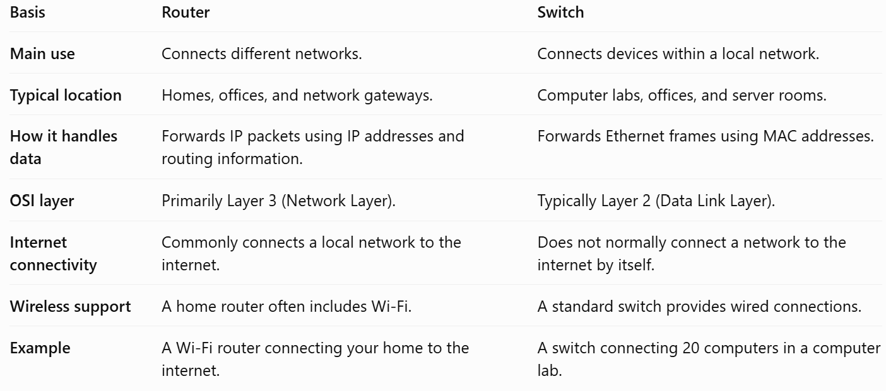
Conclusion: A router connects different networks and directs traffic between them, while a switch connects devices within the same local network. They often work together to provide network connectivity.

